**Project Plan**

**Inventory Management System**

|  |  |
| --- | --- |
| Industry Partner | Not Applicable |
| Primary Instructor | Anjana Shah |
| Team Member | Rajat Rajat |
| Team Member | Nirav Sorathia |
| Team Member | Muskan Batra |
| Team Member | Gourav Gourav |

**Document Revision History**

|  |  |
| --- | --- |
| Revision # | Date |
| 1 | October 02,2019 |
| 2 | October 03,2019 |
| 3 | January 13,2019 |

**Table of Contents**

1 Executive Summary 3

2 Project Approvers, Reviews and Distribution List 3

3 Scope 3-4

4 Deliverables 4

5 Assumptions 4

6 Dependencies 5

7 Risk Management 5

8 Communication 5

8.1 Reportings 5

8.2 Meetings 5-6

9 Task Listing (WBS- Work Breakdown Structure)……………………………………………………………..6

10 Gantt Chart 6-7

11 Milestones 7

12 RAM – Responsibility Assignment Matrix 8

13 Approval 8

**1. Executive Summary**

The following describes the project to be executed.

|  |  |
| --- | --- |
| Objective | * To create an application that meets the needs and desires of the business owner to increase the sales and minimize inventory investment. * To have all the required features in the application an individual need in his company’s inventory management software. * To make the app focused on the doing on all the inventory procedures like adding the items, ordering items, view orders, view reports and graphs and so on. * To make user less reliable on third party so that the company can manage their data by themselves. |
| Corporate Goals Addressed | * To easily add and delete an item in the app. * To know abut the remaining and the sold stock. * To receive the notifications about the short items. * To detect the markup in the sales according to the items. * To have the ability to re-order the items in the stock. |
| Planned Start Date | 11th September,2019 |
| Planned End Date | 27th March,2020 |

**2. Project Approvers, Reviews and Distribution List**

|  |  |  |  |
| --- | --- | --- | --- |
| Project Role | Name | E-mail | Date |
| Project Manager | Nirav Sorathia | nirav.sorathia@georgebrown.ca | 10/07/2019 |
| Front End Developer | Muskan Batra | muskan.batra@georgebrown.ca | 10/07/2019 |
| Programmer | Rajat Rajat | rajat.rajat@georgebrown.ca | 10/07/2019 |
| Delivery Manager | Gourav Gourav | gourav.gourav@georgebrown.ca | 10/07/2019 |

**3. Scope**

Define the sum total of all of its products and their requirements or features.

|  |  |
| --- | --- |
| **In Scope** | **Out of Scope** |
| Point of sales, i.e. we will be presenting our inventory system by actually showing the sales of a product and the deduction of the item from the inventory respectively. | third party dependency, i.e. we are not considering the parties through which the store buys the stock. Once manager clicks on the order button, the items get adds in the inventory. |
| Damaged items, i.e. we are keeping track of the items getting damaged. | Money, i.e. price of the products and money count by the manager are not taken care by us |
| Returned item, i.e. we are keeping track of the items which are returned by the customers. | Quality of products, i.e. We are not taking the expiry dates of the |
| Cancelled order or receipt, i.e. if a customer cancels his order the items he brought gets added back to the inventory and the receipt gets cancelled from the inventory. | Theft or robbery, if story faces a robbery then the number of items in the inventory will not match the number of items actually in the store. In this case, manager actually have to count the stuff manually and then he can update the system according to the number. |
| Manager can change the quantity of the items in the inventory. i.e. if the employee eats something then manager can simply deduct the item quantity from the system. |  |

**4. Deliverables**

This project will deliver the following.

|  |  |
| --- | --- |
| **Deliverable** | **Description** |
| Check inventory items | Manager and employees of the store would be able to see the items in the inventory. |
| Add items in inventory | Manager will be able to add the items in the inventory by himself with the help of a barcode scanner. |
| Remove/sell items | Manager can remove the item from the inventory which he does not want in his store and the system will automatically remove an item from the inventory once the item gets sold. |
| Order items | Manager would be able to order the items through our system. He will also receive notifications about the items which would about to be end soon. |
| Track sales through graphs and reports | Our system will generate graphs every month to keep the track of the sales. |

**5. Assumptions**

1. *We are assuming that the store will have full connection with the internet without any interruptions as we will be using the database which will be served from cloud*
2. *We are also assuming the stakeholder to enter all the item details by himself which he wants to add in the inventory web application.*
3. *We assume the stakeholder to read the guidelines to use the application for its proper use.*

**6. Dependencies**

1. Our system is fully dependent on the database, we are using Azure MySQL database.
2. Our system will be dependent on the internet connection. In order to run the application without any problem, client must have good internet connection because connection problem could cause data lose or some other security problems.

**7. Risk Management**

|  |  |  |  |
| --- | --- | --- | --- |
| Potential Risk | Severity (H/M/L) | Likelihood (H/M/L) | Management Strategy |
| Access of Inventory database | M | L | Cloud Storage |
| Security Risk | H | L | Provide Identification, Authorization and Authentication |
| Theft | M | H | Add Manually to the system |
| Connection failure | H | H | Good connectivity |

**8. Communication**

**8.1 Reporting**

The following reports will be produced;

|  |  |  |
| --- | --- | --- |
| Report | Audience | Frequency |
| Internal information exchange | Employee | On Every Sprint |
| Information Management | Stack holders | Once in month |
| Project marketing | Customers | Once |

**8.2 Meetings**

The following meetings/communication will be established;

|  |  |  |  |
| --- | --- | --- | --- |
| Meeting | Purpose | Attendees | Frequency |
| Project initialization Meeting | Project kickoff | Project manager and whole Project team | Once |
| Stockholders Meeting | Project work review, requirement gathering and other- user side requirement updates | Project manager and Stack holders | Once in month |
| Project status Meeting | To keep project moving towards success | Project manager and whole Project team | Every week |
| Project review Meeting | Lessons learned and celebration | Project team | Once |

**9. Task Listing (WBS- Work Breakdown Structure)**

The following resource proposal template summarizes the resource hours committed to this project, upon final approval of this document.

|  |  |  |  |
| --- | --- | --- | --- |
| Reference | Tasks | Duration | Dependency |
| A | Requirement gathering | 4 weeks | No dependencies |
| B | Structure designing | 4 weeks | A |
| C | Programming | 8 weeks | B |
| D | Database handling | 4 weeks | B, C |
| E | Review and Testing | 4 weeks | C |
| F | Error Handling | 3 weeks | E |

**10. Gantt Chart**

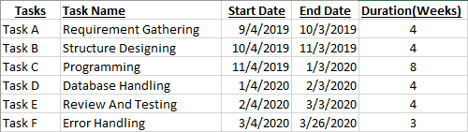

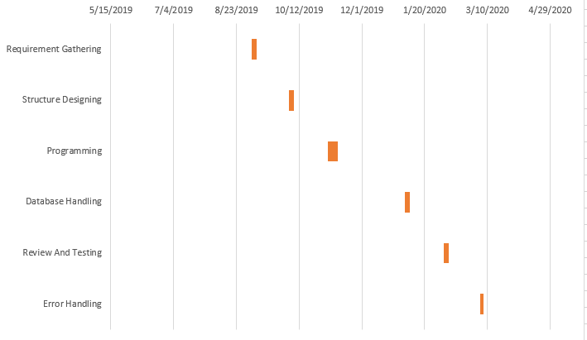

**11. Milestones**

|  |  |  |
| --- | --- | --- |
| **Major Activity or Milestone** | **Estimated Milestone Target date** | **Owner/Reviewer Team Members** |
| Project vision, business requirements, user personas and user stories | 03/28/2019 | Rajat, Gourav, Nirav, Muskan |
| Project plan, team charter, product backlog, sprint backlog | 10/06/2019 | Rajat, Gourav, Nirav, Muskan |
| Making of UI | 01/06/2020 | Rajat, Gourav, Nirav, Muskan |
| Back-End programming | 01/20/2020 | Rajat, Gourav, Nirav, Muskan |
| System implementation | 03/27/2019 | Rajat, Gourav, Nirav, Muskan |

**12. RAM – Responsibility Assignment Matrix**

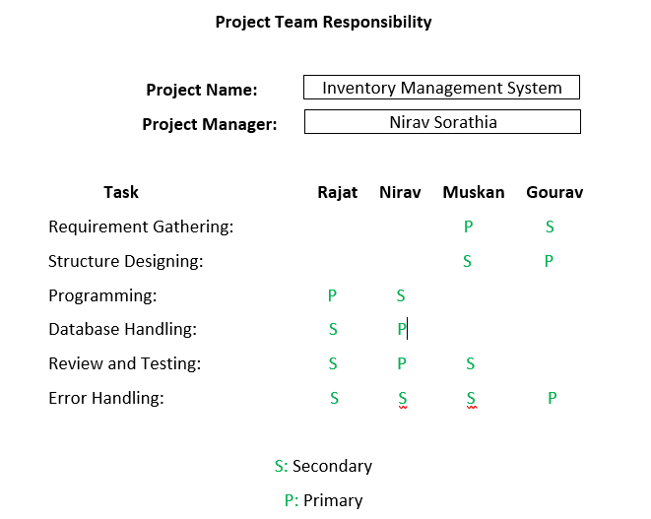

**13. Approval**

The signatures below indicate their approval of the contents of this document.

|  |  |  |  |
| --- | --- | --- | --- |
| **Project Role** | **Name** | **Signature** | **Date** |
| Project Manager | Nirav Sorathia | Nirav | 10/07/2019 |
| Front End Developer | Muskan Batra | Muskan | 10/07/2019 |
| Programmer | Rajat Rajat | Rajat | 10/07/2019 |
| Delivery Manager | Gourav Gourav | Gourav | 10/07/2019 |